Cloud Computing Lab
Lab 07 tasks
Environment Variables, PATH, UFW, and SSH Key Authentication

Submitted To: Muhammad Shoaib
Submitted From: Aimen Hafeez
Registration Number: 2023-BSE-002

Task 1 — Print & filter environment variables (Ubuntu VM)
Print all environment variables:
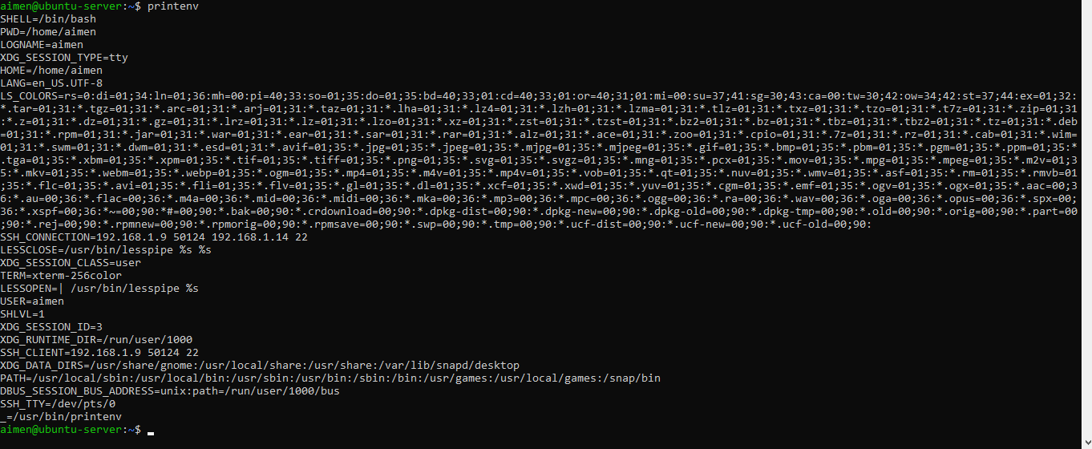

Run three greps together (run the three commands consecutively in the same terminal so one screenshot shows all three outputs).
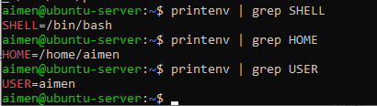

Task 2 — Export DB_* variables temporarily and observe scope
Step A — Define variables (in one block; capture all three exports together)
Run the three exports one after another:
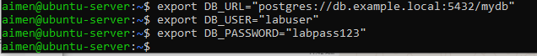

Step B — Echo them (three echoes together)
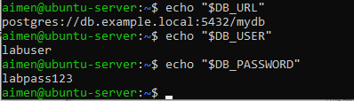

Step C — Show all DB_ envs with grep
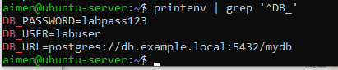

Step D — Close shell and reopen to show they disappear
Close the session:
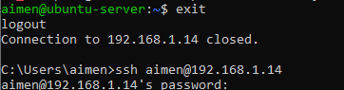
Reconnect (from the Windows host or VM console). Then run these two checks together
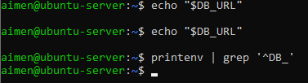

Task 3 — Make DB_* variables persistent in ~/.bashrc
Step A — Edit ~/.bashrc and add the three export lines (capture editor showing the three lines)
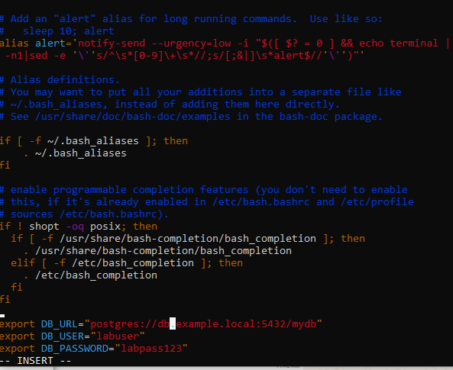

Step B — Source ~/.bashrc and verify
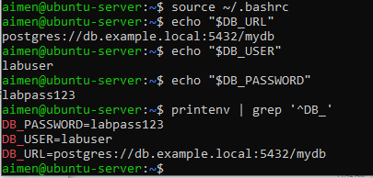

Step C — Close and reopen terminal and verify persistence
Reconnect or open a new terminal and run:
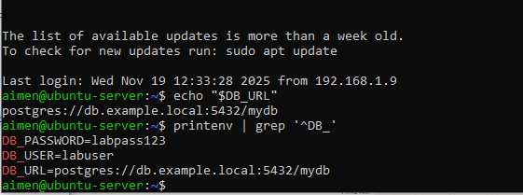

Task 4 — System-wide environment variable, welcome script, and PATH
View /etc/environment (before)
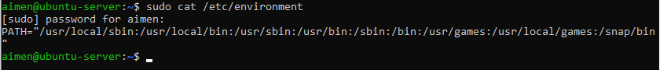

Show current PATH

Edit /etc/environment and add Class="CC-<your_class_name>"
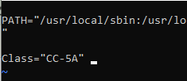

Then show the file after editing:
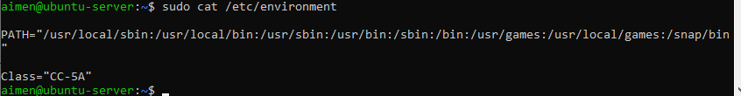

Re-login or open a new shell and show Class and PATH together
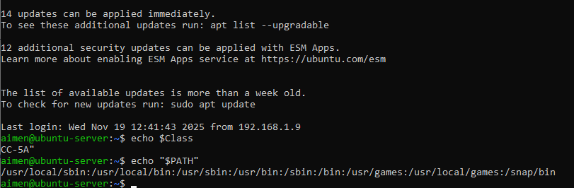

Create ~/welcome script (capture heredoc creation and chmod together if possible)
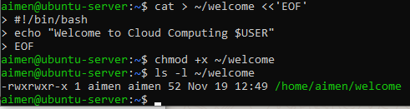

Run the script using ./welcome (from home directory)
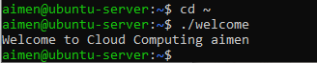

Add home to PATH in ~/.bashrc
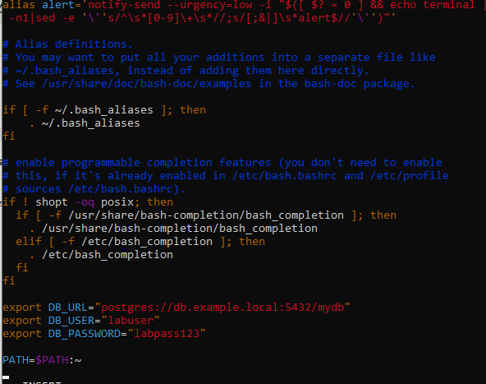
Source and run welcome
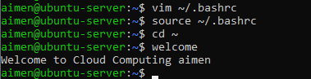

Task 5 — Block and allow SSH using ufw (firewall)
Enable ufw and show status
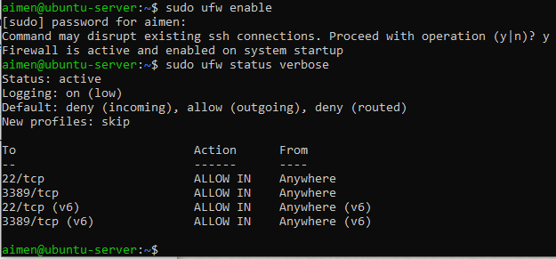

Deny TCP port 22 and show numbered status
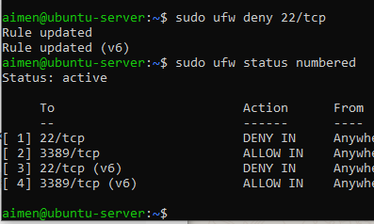

FROM WINDOWS HOST: attempt SSH (should fail) — capture client attempt

Allow SSH back and reload & show status
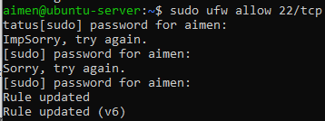
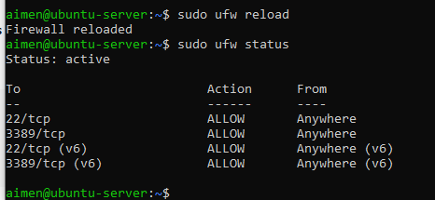

FROM WINDOWS HOST: attempt SSH again
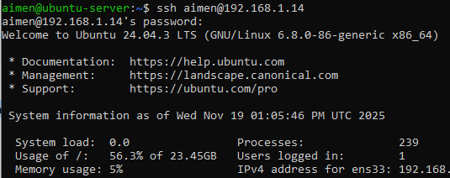

Task 6 — Configure SSH key-based login from Windows host → Ubuntu server
Part A — On Windows host (client)
Generate ed25519 key pair (group the keygen and listing of ~/.ssh)’
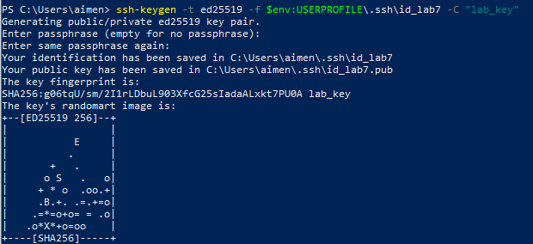
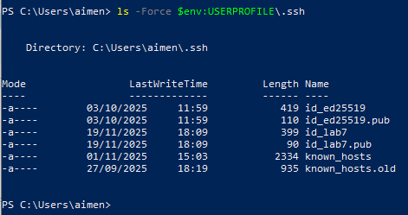

Show the public key content

Clear known_hosts and verify it's empty
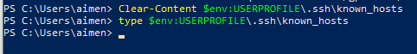
Connect to Ubuntu server to accept host key
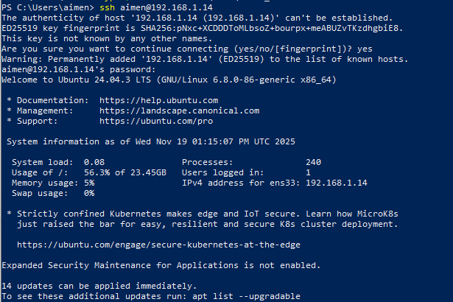

Show known_hosts after connect
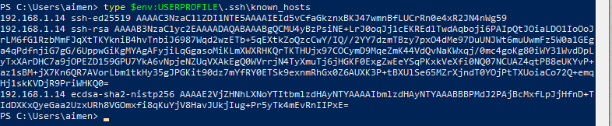

Part B — On Ubuntu server
Prepare ~/.ssh and clear authorized_keys
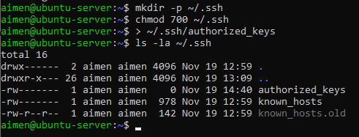

Append the public key from Windows into ~/.ssh/authorized_keys, set permissions, and show file
Using SSH session paste
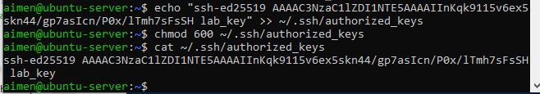

From Windows host: test passwordless login
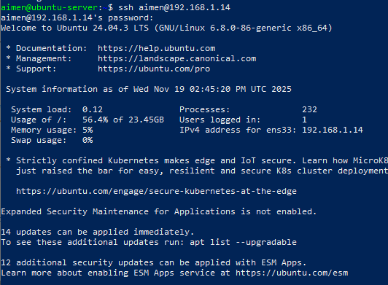

Demonstrate explicit identity usage
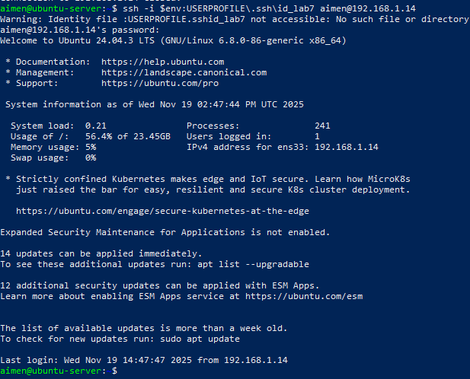

Server-side permission checks (optional verification):
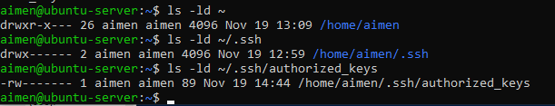

Exam Evaluation Questions
Q1: Quick Environment Audit
Display all environment variables
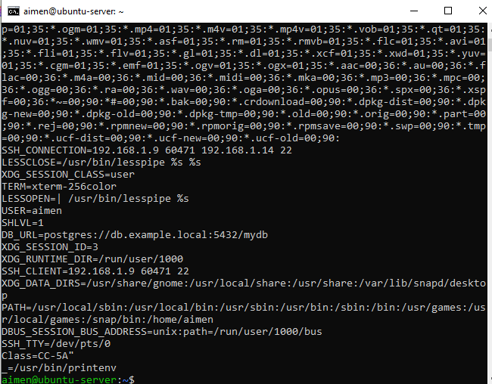

Display PATH
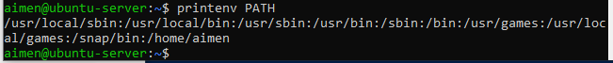

Display LANG
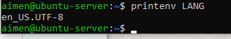

Display PWD
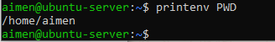

Q2: Short-lived Student Info (Temporary Variables)
Set three variables
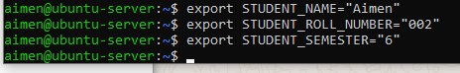

Print the values
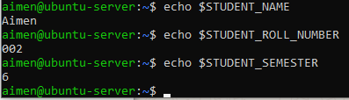

Show all STUDENT_ variables
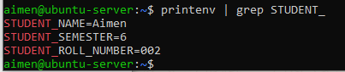

Close terminal
Open a NEW terminal
Check that variables are gone
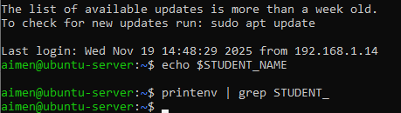

Q3: Make It Sticky (Persistent Variables)
Open bashrc file
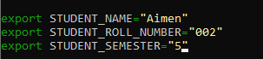

Verify variablesVerify variables
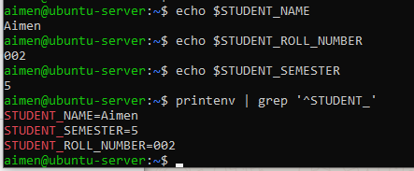

Close terminal and open a new one
Verify persistence
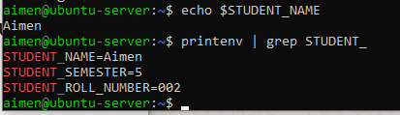

Q4: Firewall: Block & Restore Ping (ICMP) Using UFW
Enable UFW
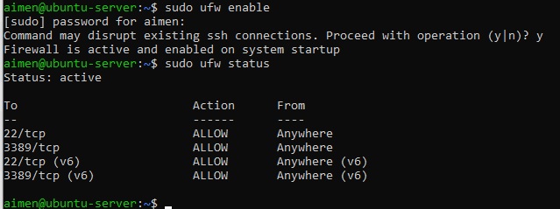
Block ping
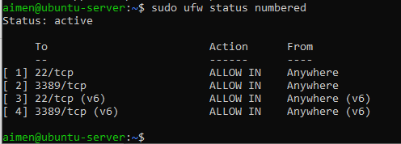

From Windows machine, run:
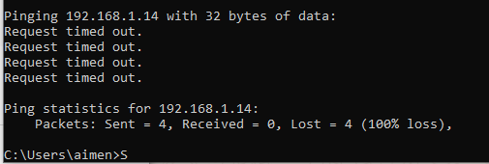

Allow ping again
Remove deny OR allow icmp
